**Assignment 4**  
Name: Denis Nadarevic  
ID: 104445626  
Due Date: November 17th, 2017

1. 007 = **63** (7(8) + 7(1))
2. 0x77 = **119** (7(16) + 7(1))
3. 0xABC = **2748** (10(256) + 11(16) + 12(1))

4. Below is an image of the initializer before being simplified:

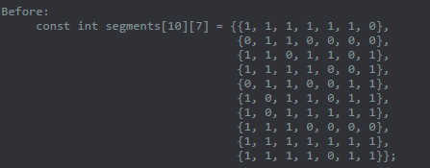

Below is an image of the initializer after being simplified:

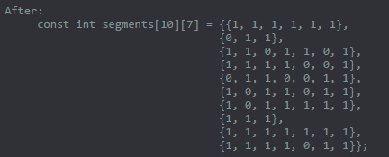

The remainder of my answers for this assignment are saved in the folder.